Chirality (Specific Rotation of Sugars) Lab

Introduction

General Background
- Plane-polarized light is created by passing ordinary light through a polarizing device, which may be as simple as a lens taken from polarizing sun-glasses. Such devices transmit selectively only that component of a light beam having electrical and magnetic
field vectors oscillating in a single plane. The plane of polarization can be determined by an instrument called a polarimeter (Figure 1). | 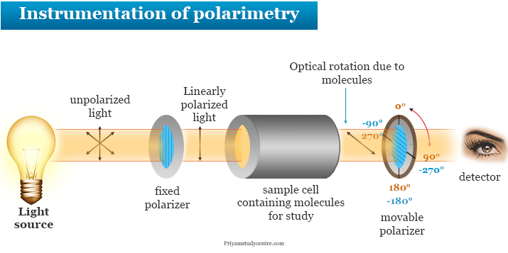
 | Figure 1: Polarimetry Basics
- Chemists use polarimeters to investigate the influence of compounds (in the sample cell) on plane polarized light. Samples composed only of achiral molecules (e.g. water or hexane), have no effect on the polarized light beam. However, if a single enantiomer is examined (all sample molecules being right-handed, or all being left-handed), the plane of polarization is rotated in either a clockwise (positive) or counter-clockwise (negative) direction, and the analyzer must be turned an appropriate matching angle, α, if full light intensity is to reach the detector.
- The observed rotations (α) of enantiomers are opposite in direction. One enantiomer will rotate polarized light in a clockwise direction, termed dextrorotatory or (+), and its mirror-image partner in a counter-clockwise manner, termed levorotatory or (–). The prefixes dextro and levo come from the Latin dexter, meaning right, and laevus, for left, and are abbreviated d and l respectively. D-glucose rotates polarized light in a clockwise direction and hence, is called dextrose. D-fructose rotates polarized light in a counter-clockwise direction and hence, is called levulose.

Biot’s Law
- For linearly polarized light the vector of the electric field $\vec{E}$ oscillates in one plane. Optically active compounds rotate the plane of oscillation of linearly polarized light. The angle of rotation, α, where the plane of oscillation is rotated around can be measured with a polarimeter. The optically active compound is placed between polarizer and analyzer. The intensity of the light behind the analyzer is thereby proportional to the concentration of the optically active compound in the solution. The angle of rotation, α, is also dependent on the length for which the light travelled through the solution. The relationship is given by Biot’s Law (Equation 1). Usually, the wavelength used is the D-line of $Na$ lamp at 589 nm. It is yellow in color. The slope of the curve when angle of rotation vs. concentration plot is constructed (α as the $x$-axis and $c$ as the $y$-axis) will give the specific angle of rotation (${\left[α\right]}_{λ}^{T}$), given we know the pathlength of the light travelling.
$$Eq. 1$$ | $$α={\left[α\right]}_{λ}^{T}∙c∙l$$ | $$α=angle of rotation$$
 |  | $${\left[α\right]}_{λ}^{T}=specific angle of rotation at T \& λ$$
 |  | $$c=concentration of the optically active compound \left(g/{mL}\right)$$
 |  | $$l=pathlength of the travelled light (dm)$$
- The compounds used in this experiment are D-glucose or dextrose, or levulose and sucrose (table sugar – a dimer of D-glucose & D-fructose).
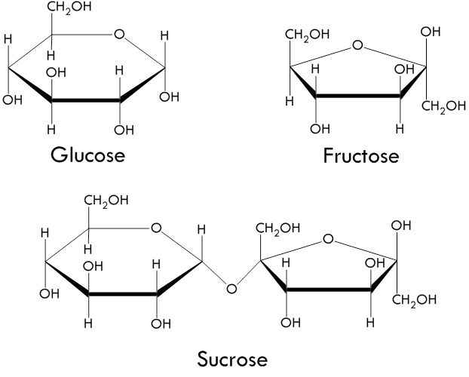 |  | 
Figure 3A: D-glucose | Figure 3B: D-fructose | Figure 3C: sucrose

General Lab Safety Rules
- Treat all chemicals as toxic
- Ask your instructor whenever you have questions
- No food, no drink, no smoke
- Clothes cover shoulder, shoes cover toes
- Long hair must be tied up
- Clean up glassware and work surface after lab
- Wash hands before you leave
- SDS Information: D-Glucose or Dextrose (SDS 211), D-Fructose or Levulose (SDS 205), Sucrose (SDS 159)

Experimental

Sample Procurement
- LABEL 3 DIFFERENT 50 mL beakers with the names of the sugars.
- All the sugar solutions are colorless and look identical.
- Obtain 30 mL of the 3 different 30% sugar solutions. BE CAREFUL!!! DO NOT take too much more than 30 mL.

Solution Preparation for the Calibration Curve
- Use 10 mL volumetric flasks to make the solutions of known concentrations.
- Use a graduated pipette to transfer the required volumes of the 30% sugar solutions to the 10 mL volumetric flasks.
- Use DI water to fill the flask upto the mark. Read the lower meniscus. BE CAREFUL!!! DO NOT go above the mark and thus wasting solutions. IF you go above the mark, you will need to discard the solution and start from the beginning. There MAY NOT be extra solution to spare.
- Record the temperature of your prepared solutions using a thermometer. Measure the blank solution first and then proceed according to the increasing concentration of the same sugar.
- Wash the thermometer bulb with DI water when switching between two different sugars.

Polarimeter Set-Up
- Plug power cord into the LabQuest 2. Turn it on.
- Find the Dig 1 and Channel 1 ports on the LabQuest 2 console. Look for the polarimeter cords labelled Dig 1 and Ch 1. Plug the right cords in the right port.
- On the LabQuest 2 console, you will see Dig 1 is relative illumination and Ch 1 is angle of rotation.
- Turn on the computer if it is not already on.
- Use the mini cable provided to connect the LabQuest 2 console to the computer.
- Open the program LoggerPro 3 on the computer. You should find the icon on the desktop. The program will automatically detect the device. If not, no device connected will be shown.

Polarimeter Calibration
- Pour distilled water in the Polarimeter cell to a height of 10 cm. It is important to read the height to the nearest 0.1 cm. Read the lower meniscus.
- Place the cell in the Polarimeter.
- Start data collection (hit the button with a green arrow at the bottom left end of the screen) and slowly rotate the analyzer clockwise or counterclockwise (Figure 4) until data collection stops (15 s) (the previously mentioned button appears with a red box in it). Slowly rotating the analyzer produces smoother curves. only rotate the analyzer while data collection is active. Allow a few seconds at both the beginning and ending of data | 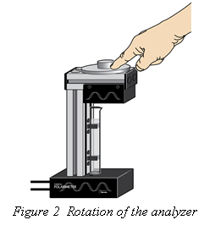
 | Figure 4: Analyzer
collection without moving the analyzer.
- Save the data on the LoggerPro 3 program. Name the file as you wish.
- On the LabQuest 2 console screen, find the “Run 1”. Right beside that will be the save button. Note down the Run # for your blank.

Optical Rotation Data Collection
- Pour the lowest concentration sugar sample in the Polarimeter cell upto the 3 cm mark. Record the height of the solution value to the nearest 0.1 cm. Read the lower meniscus for an accurate value.
- Follow the same procedure as described in the calibration section. Note down the Run # for your sample (both the identity and the concentration of the sugar).
- Collect the data for each concentration value of each of the different sugars in the same way.
- Save the data as described before.

Data Table 1: Sugar Solution Preparation |  |  |  | Solution Temperature |  |  |  |  | °C
Volume of 30% Solution | $$(mL)$$ | 0.00 | 3.30 |  | 6.70 | 8.30 |  | 10.00
Total Volume of Solution | $$(mL)$$ | 10.00 | 10.00 |  | 10.00 | 10.00 |  | 10.00

Results & Discussion

Curve Fitting using Gaussian
- Open the saved runs one at a time in the LoggerPro 3 on the computer starting from Run 1.
- Locate the first angle above 0° where the illumination is at a maximum. Highlight the peak of interest. For best results, be consistent in the way you select your peaks throughout ALL the runs.
- Choose ‘Curve Fit’ from the ‘Analyze’ menu. From the list of available ‘General Equations’, select ‘Gaussian’. Select ‘Try Fit’.
- The B coefficient represents the angle at maximum illumination. Record the data in the appropriate cell in the Data Table 2.

Curve Fitting Using Cosine Squared
- Repeat the process described in the ‘Curve Fitting using Gaussian’ changing the selection to ‘Cosine Squared’ from the list of available ‘General Equations’.
- The negative value of the C coefficient represents the angle at maximum illumination. Record the data in the appropriate cell in the Data Table 3.

Specific Angle of Rotation by Graphical Method
- Two different graphs will be used to find the specific angle of rotation of the sugars.
- For the graph using the Gaussian data, subtract the blank value from the B values of each of the concentrations (Data Table 4).
- Repeat the same process for the -C values for the Cosine Squared data (Data Table 4).
- Plot the graphs in MS Excel program. The Gaussian data for ALL the sugars will be in one graph (Figure 5A). The Cosine Squared data for ALL the sugars will be in one graph (Figure 5B). DO NOT have innumerable graphs in your report. Have the graphs sized properly to fit in the spaces provided.
- Graphs MUST have: Axes values & labels (with units), legends properly labelled, trendline equations, $R^{2}$ values
- Identify the slopes in each of the graphs and record them (Data Table 5).
- Use equation 1 (Eq. 1) to compute the specific angle of rotation of the sugars using your pathlength in $dm$ and report your data (Data Table 5).
Data Table 2: Concentration Determination |  |  |  | Solution Temperature |  |  |  |  | °C
Volume of 30% Solution | $$(mL)$$ | 0.00 | 3.30 |  | 6.70 | 8.30 |  | 10.00
Total Volume of Solution | $$(mL)$$ | 10.00 | 10.00 |  | 10.00 | 10.00 |  | 10.00
Solution Concentration | $$\left(g/{mL}\right)$$

Data Table 3: Optical Rotation Data |  |  |  | Pathlength |  |  |  | $$cm$$ |  |  | $$dm$$
Solution Concentration | D – Glucose or Dextrose |  | D – Fructose or Levulose |  |  |  | Sucrose or Table Sugar
$$\left(g/{mL}\right)$$ | B (Gaussian) | -C  (Cos Sq.) | B (Gaussian) |  | -C  (Cos Sq.) |  | B (Gaussian) |  |  | -C  (Cos Sq.)

Data Table 4: Determination of Specific Angle of Rotation by Graphical Method
Solution Concentration | D – Glucose or Dextrose |  | D – Fructose or Levulose |  | Sucrose or Table Sugar
$$\left(g/{mL}\right)$$ | corrected B | corrected  -C | corrected B | corrected  -C | corrected B | corrected  -C

Figure 5A: Gaussian Curve Fit Graph | Figure 5B: Cosine Squared Curve Fit Graph

Data Table 5: Specific Angle of Rotation Report |  |  |  |  | Solution Temperature |  |  |  |  | °C
Sugar | Literature Value | Gaussian Slope | Gaussian ${\left[α\right]}_{λ}^{T}$ | Error% |  | Cos. Sq. Slope | Cos. Sq. ${\left[α\right]}_{λ}^{T}$ |  | Error%
D-Glucose | +52.2°
D-Fructose | -92.4°
Sucrose | +66.6°

Conclusions
- Research about specific angle of rotation of sugars. Carefully analyze the factors involved. Based on your research, explain your error percent.
- Which of the curve fittings (Gaussian & Cosine Squared) yielded better result and why?

